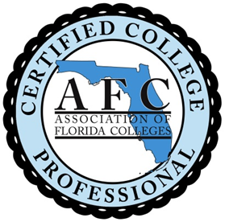 | Association of Florida Colleges  College Professional Program  Legislative Process and Advocacy  July 18, 2017 8:30 a.m. – 3:30 p.m.  10 CCP Credits  Florida SouthWestern State College  Building U, Room 106  Thomas Edison Campus  8099 College Parkway  Ft. Myers, FL 33919
8:30 a.m. – 9:00 a.m. Continental Breakfast and CCP Participant Networking
9:00 a.m. – 9:30 a.m. Welcome and Introductions
Dr. Robert Flores, AFC President and Mike Brawer, AFC CEO

9:15 a.m. – 9:30 a.m. Icebreaker
Charlene Latimer, Chair, CCP Program

9:30 a.m. – 10:30 a.m. How A Bill Becomes Law
Matthew Holliday, Director of Government Relations
Florida SouthWestern State College

10:30 a.m. – 10:45 a.m. BREAK

10:45 a.m. – 12:00 p.m. Federal Legislative Processes and Issues
Jee Hang Lee, VP for Public Policy and External Relations
Association of Community College Trustees

12:00 p.m. – 1:00 p.m. LUNCH: Room 102
1:00 p.m. – 2:00 p.m. The Florida Legislative Budget Process
Christopher Mullin, Executive Vice Chancellor
Division of Florida Colleges

2:00 p.m. – 2:15 p.m. BREAK

2:15 p.m. – 3:00 p.m. The AFC Legislative Process
Michael Brawer, CEO Association of Florida Colleges
3:00 p.m. – 3:30 p.m. Wrap-Up/Adjourn

